Module (CSS and CSS 3) -2

1. What are the benefits of using CSS?

*Separation of Concerns:*

***Benefit*:** CSS allows separation of style structure and content of a web page. This makes it easier to maintain or update a website, as changes to the visual presentation can be made without altering the HTML.

EXAMPLE:--

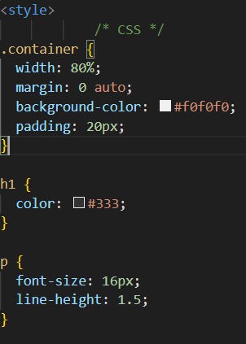

1. What are the disadvantages of CSS?

*Inconsistency in Box Model:*

***Disadvantage***: In some cases, there can other contain be inconsistencies in how different browsers interpret the box model, leading to layout issues.

EXAMPLE:--

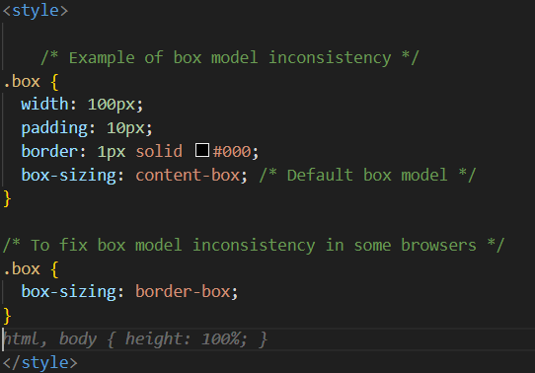

1. What is the difference between CSS2 and CSS3?

*Box Model:*

*CSS2:* The box model in CSS2 was relatively simple, with properties like width, height, margin, padding, and border.

*CSS3*: CSS3 introduced the box-sizing property, allowing for more control over how the width and height of an element are calculated, including the border-box value.

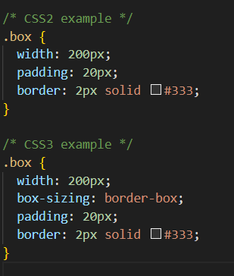

1. Name a few CSS style components?

Certainly! ***CSS*** (Cascading Style Sheets) allows you to style the visual presentation of HTML elements. Here are five CSS style components along with examples:

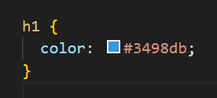 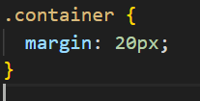

1. What do you understand by CSS opacity?

*CSS* opacity is a property that controls the transparency of an element, allowing you to make an element more or less transparent. The opacity property takes a value between.

1. How can the background color of an element be changed?

You can change the background color of an HTML element using the **background-color** property in CSS. Here's an example:

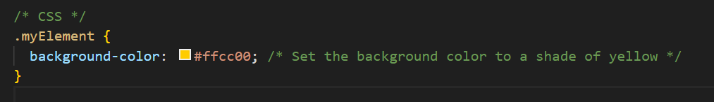

The CSS rule targets an element with the class **myElement** and sets

its background color to **#ffcc00.**

1. How can image repetition of the backup be controlled?

If you want to control the repetition of a background image in CSS, you can use the background-repeat property. This property allows you to specify whether and how a background image should repeat. There are several values you can use for background-repeat:

*repeat*: The default value. The background image will repeat both horizontally and vertically.

*repeat-x*: The background image will repeat only horizontally.

*repeat-y*: The background image will repeat only vertically.

*no-repeat*: The background image will not repeat.

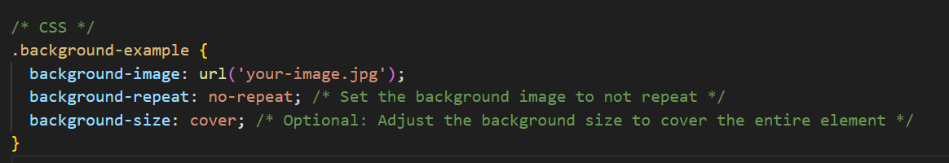

1. What is the use of the background-position property?

The **background-position** property in CSS is used to specify the initial position of a background image within its containing element. It allows you to control where the background image is placed, both horizontally and vertically. The property takes two values: one for the horizontal position and one for the vertical position.

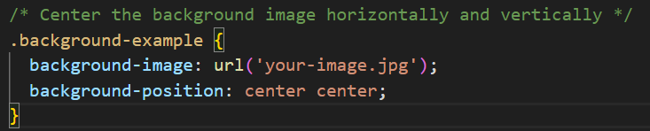

1. Which property controls the image scroll in the background?

The property that controls over scrolling behavior of a background image in CSS is the **background-attachment** property.

1. **scroll:** The background image will scroll with the content.
2. **fixed:** The background image will stay fixed in place the content scrolls.
3. **local:** The background image will scroll element's contents.

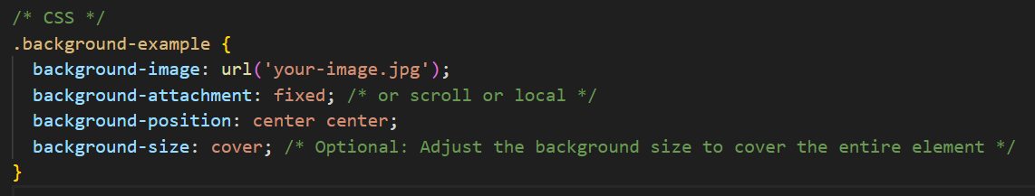

1. Why should background and color be used as separate properties?

The great-properties **background** and **color** as separate properties in CSS allows for more flexibility and control over the styling of an element's background and text content. a distinct

**background Property:**

***background*** property is a shorthand property background-related properties into one. It allows you to set multiple background properties, **background-color**, **background-image**, **background-repeat**, **background-position**, and **background-size** declaration.

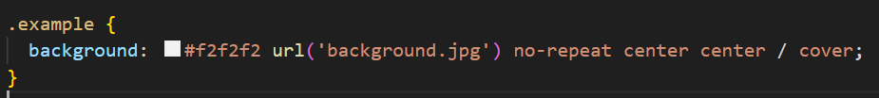

1. How to center block elements using CSS1?

Using text-align: center for Inline Elements:

If the block element is an inline or inline-block element, you can use the text-align: center property on the parent container.

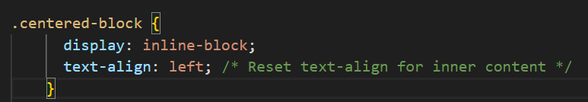

1. How to maintain the CSS specifications?

***Linting*:**

Use CSS linting tools to analyze your code for potential errors, enforce coding standards, and catch common mistakes.

***Performance Optimization:***

* Optimize your CSS for performance by minimizing the use of unnecessary styles, reducing redundant rules, and using efficient selectors.

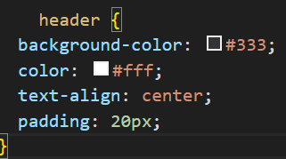

1. What are the ways to integrate CSS as a web page?

*Inline Styles:*

You can apply styles directly to individual HTML elements using the style attribute. This is called inline styling.



*Internal Styles*

Internal styles involve placing CSS directly within the HTML document. You use the <style> element within the document's <head> section.

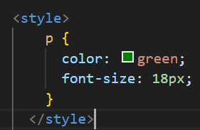

*External Styles:*

External styles involve creating a separate CSS file and linking it to your HTML document using the <link> element. This is a widely used and recommended method for larger projects.

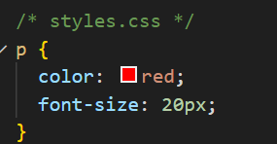

1. What is embedded style sheets?

Embedded styles, also known as internal styles, refer to the inclusion of CSS directly within an HTML document. This is achieved using the <style> element in the document's <head> section. The styles defined within the <style> element apply specifically to the HTML document in which they are embedded.

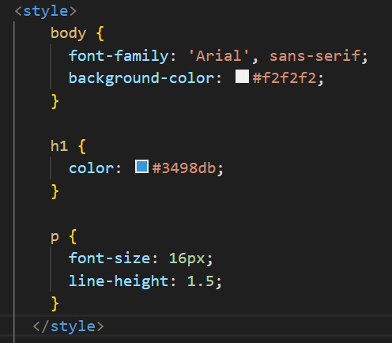

1. What are the external style sheets?

External stylesheets refer to separate CSS files that contain the styling rules for one or more HTML documents. These CSS files are created independently of the HTML content and are linked to the HTML documents using the <link> element. This approach promotes modularity, reusability, and easier maintenance, as the same stylesheet can be applied to multiple HTML pages.

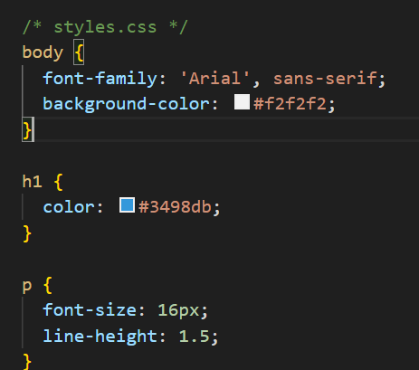

1. What are the advantages and disadvantages of using external style sheets?

*Advantages*:

*Modularity*:

Advantage: External stylesheets promote modularity by allowing you to organize your styles into separate files. This makes it easier to manage and update specific parts of your styling.

*Reusability*:

Advantage: The same external stylesheet can be linked to multiple HTML documents. This promotes consistency across a website, as changes made to the stylesheet are reflected on all linked pages.

*Disadvantages*:

*Additional HTTP Request*:

*Disadvantage*: Each external stylesheet requires a separate HTTP request. While this is usually not a significant issue for smaller websites, it can impact performance, especially if a site uses many small CSS files.

*Rendering Blocking*:

*Disadvantage*: External stylesheets can block the rendering of a page until they are downloaded and applied. This can potentially slow down the initial page load, especially if the stylesheet is large or hosted on a slow server.

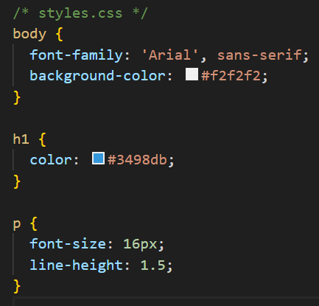

1. What is the meaning of the CSS selector?

Selectors can target elements based on various criteria, such as element type, class, ID, attributes, and their relationships within the HTML structure. Here are some common types of CSS selectors:

*Type Selector:*

***Targets elements based on their HTML tag name***

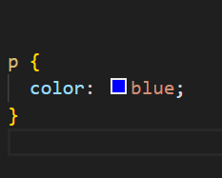

*Class Selector:*

Targets elements with a specific class attribute.

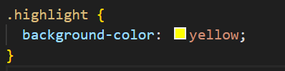

*ID Selector:*

Targets a specific element based on its unique ID attribute

1. What are the media types allowed by CSS?

CSS (Cascading Style Sheets) supports different media types, allowing you to define styles specifically for different types of devices and media. The @media rule is used to apply styles based on the specified media type:-

Ex:-1

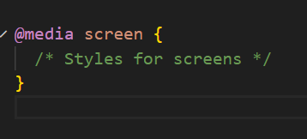

Ex:-2

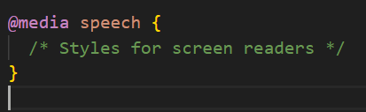

1. What is the rule set?

A rule set in CSS consists of one or more CSS rules that define the styling for a specific set of HTML elements. Each rule set is comprised of a selector and a declaration block, which contains one or more declarations.

***Selector***: It defines which HTML elements the rule set will apply to. Selectors can target elements based on various criteria such as element type, class, ID, attributes, and relationships within the HTML structure.

***Declaration Block***: It is enclosed within curly braces {} and contains one or more declarations. Each declaration consists of a property and its corresponding value. Declarations specify the style or behavior applied to the selected elements.

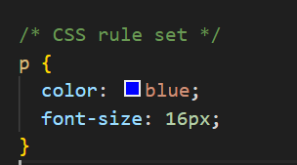

-------------------------------------------***Complete*** -------------------------------------------------